ST. XAVIER'S COLLEGE

**(Affiliated to Tribhuvan University)**

Maitighar, Kathmandu



**COMPUTER GRAPHICS**

**LAB ASSIGNMENT # 1**

**SUBMITTED BY:**

Biraj Poudyal  
013BSCCSIT015

**SUBMITTED TO:**

|  |  |
| --- | --- |
| **Er. Anil k. Sah**  Lecturer,  Department of Computer Science  St. Xavier’s College |  |

**Date of Submission:** 4th August 2015

Source code:

//---------------------------------------------------------------------------

#include <vcl\vcl.h>

#pragma hdrstop

#include "Unit1.h"

//---------------------------------------------------------------------------

#pragma resource "*.dfm"

TForm1 *Form1;

//---------------------------------------------------------------------------

__fastcall TForm1::TForm1(TComponent* Owner)

: TForm(Owner)

{

}

//---------------------------------------------------------------------------

void __fastcall TForm1::Button1Click(TObject *Sender)

{

// to draw rectangle

Form1->Canvas->Pen->Width=3;

Form1->Canvas->Brush->Color=clBlue;

Form1->Canvas->Rectangle(10,10,200,200);

// to draw line

Form1->Canvas->MoveTo(10,10);

Form1->Canvas->LineTo(200,10);

Form1->Canvas->MoveTo(10,57.5);

Form1->Canvas->LineTo(200,57.5);

Form1->Canvas->MoveTo(10,105);

Form1->Canvas->LineTo(200,105);

Form1->Canvas->MoveTo(10,152.5);

Form1->Canvas->LineTo(200,152.5);

Form1->Canvas->MoveTo(10,200);

Form1->Canvas->LineTo(200,200);

Form1->Canvas->MoveTo(57.5,10);

Form1->Canvas->LineTo(57.5,200);

Form1->Canvas->MoveTo(105,10);

Form1->Canvas->LineTo(105,200);

Form1->Canvas->MoveTo(152.5,10);

Form1->Canvas->LineTo(152.5,200);

Form1->Canvas->MoveTo(10,10);

Form1->Canvas->LineTo(200,200);

Form1->Canvas->MoveTo(200,10);

Form1->Canvas->LineTo(10,200);

}

//---------------------------------------------------------------------------

Output:

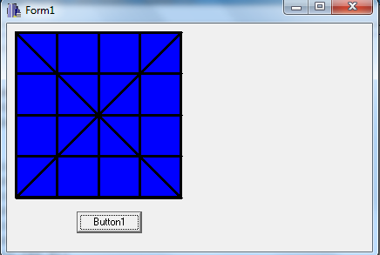

Conclusion:

Hence the checkbox is made using C++ Builder.